Zach Tzavelis

ME465 - Sound and Space

02/20/2020

HW3: RMS, Linear and Time Averaging

**Exercise 1**

The task was to create three functions: one that performed asynchronous averaging (RMS Average of Spectral Density) and two that performed asynchronous averaging (Linear and Time-Average). The asynchronous RMS averaging involved breaking the signal into smaller time chunks, computing the spectral density of each piece, and then averaging the amplitude at the each frequency. The synchronous linear averaging involved breaking the signal into evenly sized pieces, computing the FFT to convert into the frequency-domain, averaging the complex numbers at each frequency, and then computing the spectral density of the averaged frequency-domain signal. Similarly, the synchronous time-average signal involved breaking the signal into components and immediately averaging them in the time domain before computing the power spectral density. The two synchronous methods are expected to be identical since the same phase information exists when the averaging takes place (and the random phase cancels out). To test the functions, a 16 second sine wave (fs: 1024 Hz) with a frequency of 400 Hz hidden in noise was analyzed, and revealed a peak at the expected signal frequency (Figure 1).

Figure 1: Power Spectral Density of 400 Hz Sine Wave

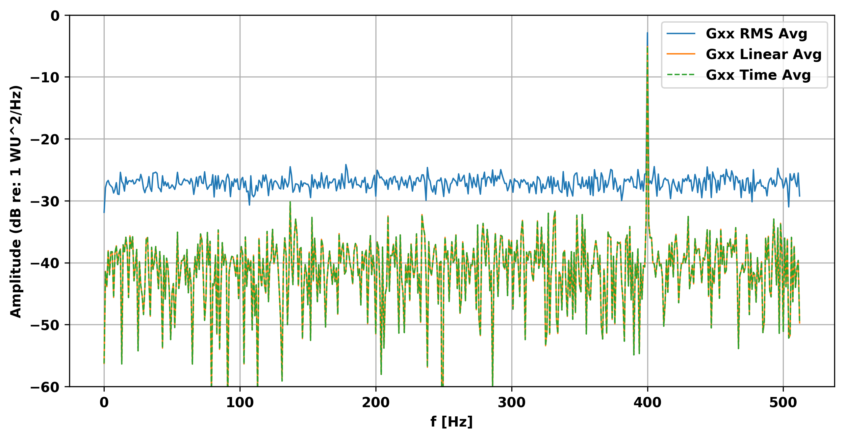

**Exercise 2**

The task was to analyze the three power spectral density averages of a repeating pulse hidden in noise (pulsenoise.wav). 256 averages were used to perform all three signal averages because the original signal (pulse.wav) contained 1024 samples, and the noisy signal contained a little over 256*1024 samples — necessitating a small truncation of about 50 samples at the end of the signal. Figure 2 plots the results of the three signal averages: the RMS averaged signal (asynchronous) has the least amplitude variability but only the first four overtones are easily visible. In contrast, the linear and time averaged signals (synchronous) have greater variability in amplitude, but more overtones are visible (at least eleven). Furthermore, the linear and time averaged signals were identical (as expected) and all three signals indicated the fundamental frequency at 257.8 Hz with the same amplitude.

Figure 2: Pulse-noise Power Spectral Density (256 Averages)

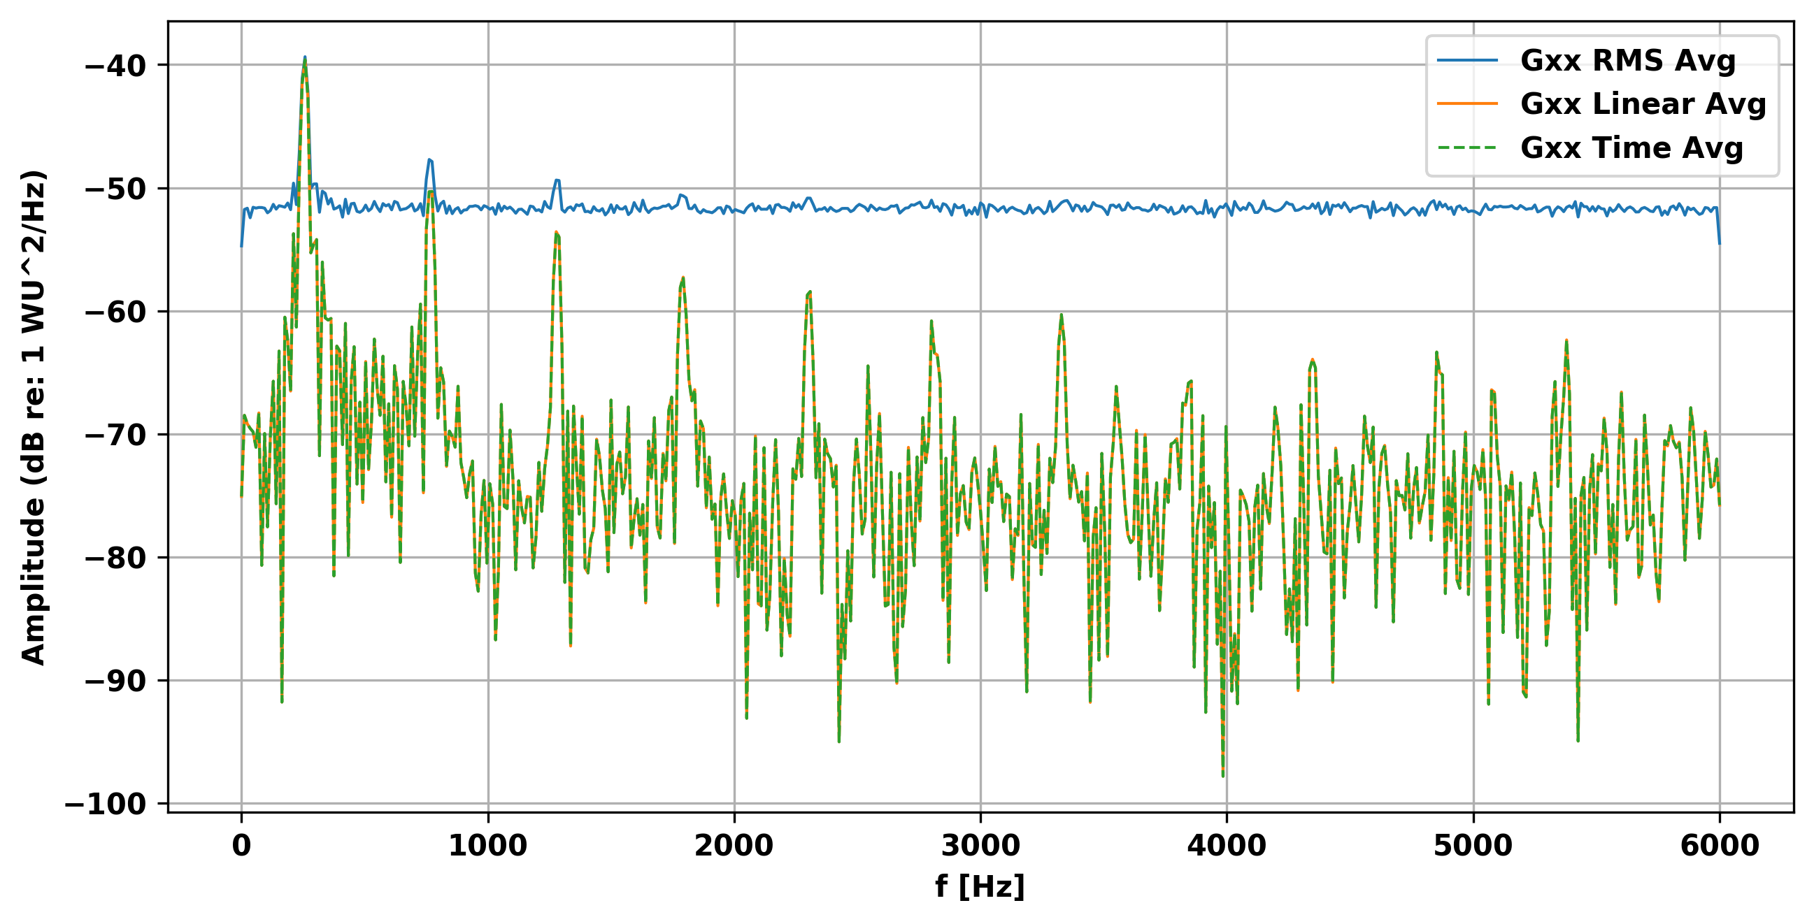

**Concluding Remarks**

The first major take away is that to compare the different averaging methods it is necessary to use the same number of averages; in this assignment, it was necessary to leverage knowledge of the length of one pulse and the fact that it was repeated in the noisy signal. The second major insight is that synchronous averaging preserves the signal’s phase information during the averaging process, thereby allowing the random phase from the noise to cancel out. RMS averaging does not allow for the random noise information to cancel because calculating the power spectral density (Sxx and Gxx) involves taking the magnitude of the linear spectrum (X), expressed with complex numbers (and therefore contains phase information), thereby converting it to real numbers that don’t contain have phase information.